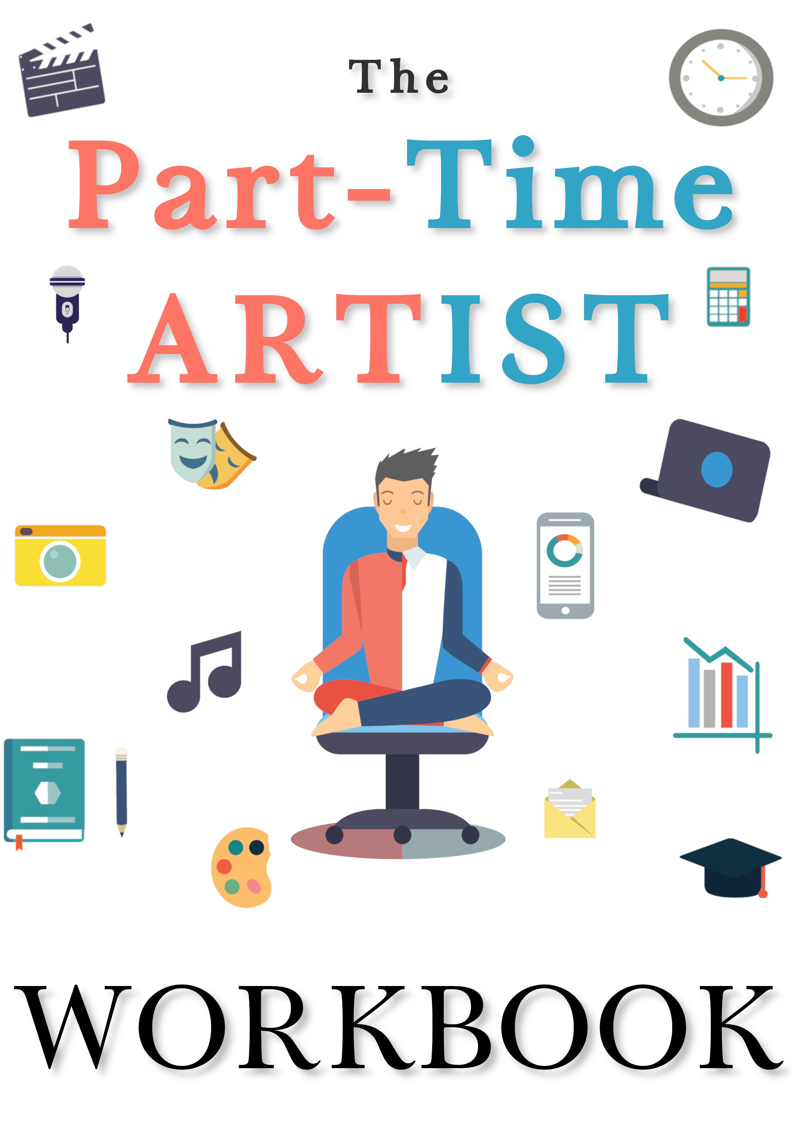

The Part-Time Artist

Workbook

By

Céline Terranova

Copyright © Céline Terranova 2019

Website: theparttimeartist.com
Email: info@theparttimeartist.com

INTRODUCTION

This workbook contains questions asked in The Part-Time Artist and gives you space to write down your answers.

This guide exists in PDF, Word and OpenOffice format, so you can print and write, or complete the blanks by computer.

The aim is to help you, so use it the way you want! There is no good or bad way of doing this, it is your journey, your choice!

In addition to this guide, you can find more helpful tools at:

https://www.theparttimeartist.com/helpful-tools

CHAPTER 1
_____

WHAT ARTIST DO YOU WANT TO BE?

- Different Types of Artists

There are three types of artists: casual, balanced and hardcore. Which one are you? Which one would you like to be, and why?

- Making It

What is your version of “making it”? What is the sign that you have succeeded? Be specific.

CHAPTER 2
_____

MOTIVATION

WHY WE DO WHAT WE DO

- Find Your “Why”

Why do you do your art? Take a few minutes to think about it and write down all the reasons. Go into as many details as you need. Don’t hesitate to write down examples! And be honest. If you do what you do to get a recognition, to become famous, write it down. Be true to yourself, nobody else has to know!

Once this is done, pin that down on a wall in front of your work station or above your bed. Read it every day. Reflect on it. Add to it, if necessary. These are your strongest motivators. The same way some people pin the picture of their dream car or their dream house to be motivated earning enough money to get them.

MOTIVATION VS HABITS

- What Habit Will You Build?

Write down the habits that you have decided to build:

Cue:

Routine:

Reward:

Cue:

Routine:

Reward:

Cue:

Routine:

Reward:

If there are bad habits that you have decided to change, you can also write them down:

Cue:

Old Routine:

New Routine:

Reward of the new routine:

Cue:

Old Routine:

New Routine:

Reward of the new routine:

CHAPTER 3
_____

TIME MANAGEMENT

ORGANISE YOUR TIME

- Your Time Planner

Take some time to think about the week to come on a day that makes sense to you (for ex: Monday morning). Think about the activities that you will have to do this week. Use fun colours to illustrate the different categories. Plan your creative time. Even if at first you can only give yourself half an hour per week. Highlight those times and make your family aware that your will be creating during them.

Fill up the Weekly Planner document that you can download from the website:

https://www.theparttimeartist.com/helpful-tools

DEFINE YOUR GOALS

- Progress in Art

What are you artistic KPI's (Key Performance Indicators)?

- Setting Goals

What are your SMART goals (Specific, Measurable, Achievable, Relevant, Time-bound)?
CHAPTER 4
_____

ENERGY & HEALTH

ENERGY TO CREATE

- What Depletes Your Energy

Make a list of all the activities and situations that demand a lot from you. Be specific. “Working” is not enough. Try “this particular deadline at work”.

Once this is done, write down what you can do about it: eliminate, reduce, delegate, do it less perfectly, pay someone to do it, keep but not overthink it, do it first thing in the morning,...

- Sleep, Nutrition, Exercise

What are your habits in these areas? Observe and describe how you sleep, what you eat and what exercises you do. Do you feel like you need to change something? What and how? Which habits will you build around this?

HEALTH AND ART

- How to Create in These Conditions?

If you have a health issue or a disability that impacts your creativity, what are the ways around it? Can you schedule your creative sessions around it? For example, if you are in more pain or more tired in the evening, perhaps you can plan all your sessions in the morning? If you know there’s a time of the month or the year where it is more likely to flare up, maybe you can plan fewer goals around that time. Are there tools that you can use to work around it?

CHAPTER 5
_____

MENTAL HEALTH

ISSUES ARTISTS FACE

Do you struggle with mental health issues? How does it feel for you? How does it impact you and your art? What does it prevent you from doing?

HELP YOURSELF

Have you tried to help yourself, and how? Did it work? Did it fail?

Is there a strategy in this book that could help you? When do you plan on trying it? How?

CHAPTER 6
_____

DAY JOB & MONEY

THE JOB THAT WORKS WITH YOUR ART

- What Kind of Job?

If you think about getting a job or changing job: What kind of job should you do? Think about organisation, your skills, your goals and the structure you would like. Do you want a temporary job or a career? Do you have all the tools you need? Is it the right time? Do you have a plan?

- Your Day Job

If you already have a job: Assess honestly your activity. Does it work with your art? Does it leave you enough time or energy to work on your projects? Do you feel miserable or is there a silver lining?

Are you able to draw a line between your work time and your art time? If not, why not? What could you change to achieve separation?

Do you have plans to progress in your job? How will that work in a few years?

MAKING MONEY

- Budgeting

Use the spreadsheet available on the website to write all your spendings:

https://www.theparttimeartist.com/helpful-tools

Observing your spendings during a couple of months can help you identify trends and usually some unnecessary spendings.

The next step is to add what you should spend in these categories. Your “target”.

Then write how much you earn. At the end of the month, calculate the difference between what you earn and what you spend, your “Money Pot”.

Divide the pot into different categories, that accumulate over time. At the end of the year, you'll have an accurate representation of your financial situation.

- Is Money the Root of Evil?

Do you have a bad relationship with money? Where does it come from? Is it justified? Does it prevent you from progressing and making enough money to survive?

- Spending Money on Your Art

How can you spend less money on your art?

- Make Money From Your Art

Can you make some money out of your art? Can you sell something? Or appear in a paid gig?

Assess what it feels like to get money for your creation. Did you enjoy the process? Do you want to repeat? Or did the project drag along? Do you want to try with something different? Or is it definitely not for you?

- Taxes

Write down your expenses and revenues as they come, and keep a record. Use the spreadsheet available on the website:

https://www.theparttimeartist.com/helpful-tools

Every month, print the corresponding sheet and file it along with receipts, invoices and other proofs needed.
CHAPTER 7
_____

GOING FULL-TIME

PROS AND CONS

- Stability vs Freedom

What do you value most?

- Who Do You Want to Be?

Do you see yourself rocking the day job and enjoying a good balance with your art? Or do you feel better imagining yourself as a self-employed person? Do you imagine having a team working under you?

YOUR ARTISTIC BUSINESS

- Your business Plan

Why?

Why do you want to do your art? Why do you feel like you should do it full-time?

Why this in particular?

Why is it the right time?

What?

Make a list of everything that you could do to make money related to your art:

Who?

Who are your customers?

Why are you the best person for this job?

When?

What is your deadline?

How?

How are you going to receive money?

How much money do you need exactly?

How much money can you make per product / service? How many do you need to sell?
CHAPTER 8
_____

BEING HAPPY

- Being Happy Now

What is good and happy in your life currently? What can you be grateful about?

- Keep the Spark

Do you feel like giving up?

What changes could you make to keep creating?

- Give Back

How can you help other artists?

Who can you help?

CONCLUSION

Thank you for joining me on this adventure. I hope that you found this workbook helpful!

What’s next? If you are interested in knowing more on this subject, you can join the discussion on The Part-Time Artist website:

https://theparttimeartist.com/

GOING FURTHER

Why not attending one of my workshops or have me work with you on your artistic career?

I have different solutions, from individual sessions to group ones, online or IRL, for all ranges of budgets. Let me help you achieve the right balance and do more with your life!

If you are interested, drop me an email:

info@theparttimeartist.com

